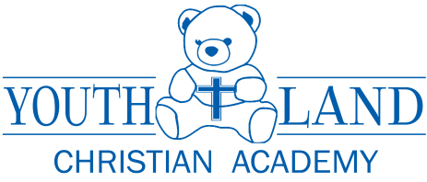

I have fully read and understand the Youthland Christian Academy Parent Handbook. I understand and acknowledge my acceptance of the policies stated within this Handbook. I have been offered an opportunity to ask questions. I will direct any further questions or concerns to my director.

I understand that this Handbook represents only current policies and benefits, and that it does not create a contract. Youthland Christian Academy retains the right to change these policies as it deems advisable.

I have received a copy of this Handbook.

Child’s Name
(please print)

Parent Signature ____

Center: Delray Beach / Boynton Beach

Director Signature
_________________________________________

Date: ____________________

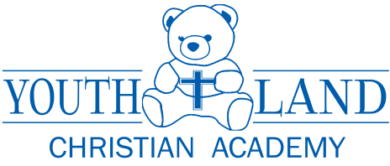

I have fully read and understand the Youthland Christian Academy Parent Handbook. I understand and acknowledge my acceptance of the policies stated within this Handbook. I have been offered an opportunity to ask questions. I will direct any further questions or concerns to my director.

I understand that this Handbook represents only current policies and benefits, and that it does not create a contract. Youthland Christian Academy retains the right to change these policies as it deems advisable.

I have received a copy of this Handbook.

Child’s Name
(please print)

Parent Signature

Center: Delray Beach / Boynton Beach

Director Signature
_______________________________________________

Date: ____________________

